Project Development Phase
Model User Acceptance Test

Date | 20 February 2025
Team ID | LTVIP2026TMIDS80982
Project Name | Prosperity Prognosticator: Machine Learning for Startup Success Prediction
Maximum Marks | 10 Marks

User Acceptance Testing:
S.No. | Parameter | Description | Screenshot
 | Input Page Testing | The “Enter Startup Details” page allows users to input startup information. The Predict button successfully submits the data to the backend model. | 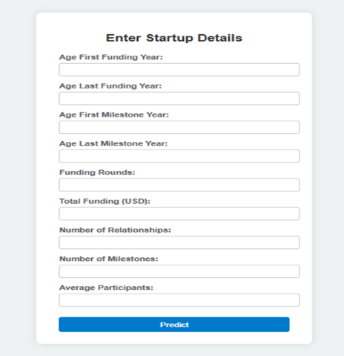
 | Output Page Testing | The “Startup Success Prediction” page displays the predicted status (Acquired/Closed) along with the confidence score. The “Predict Another Startup” option works correctly. | 